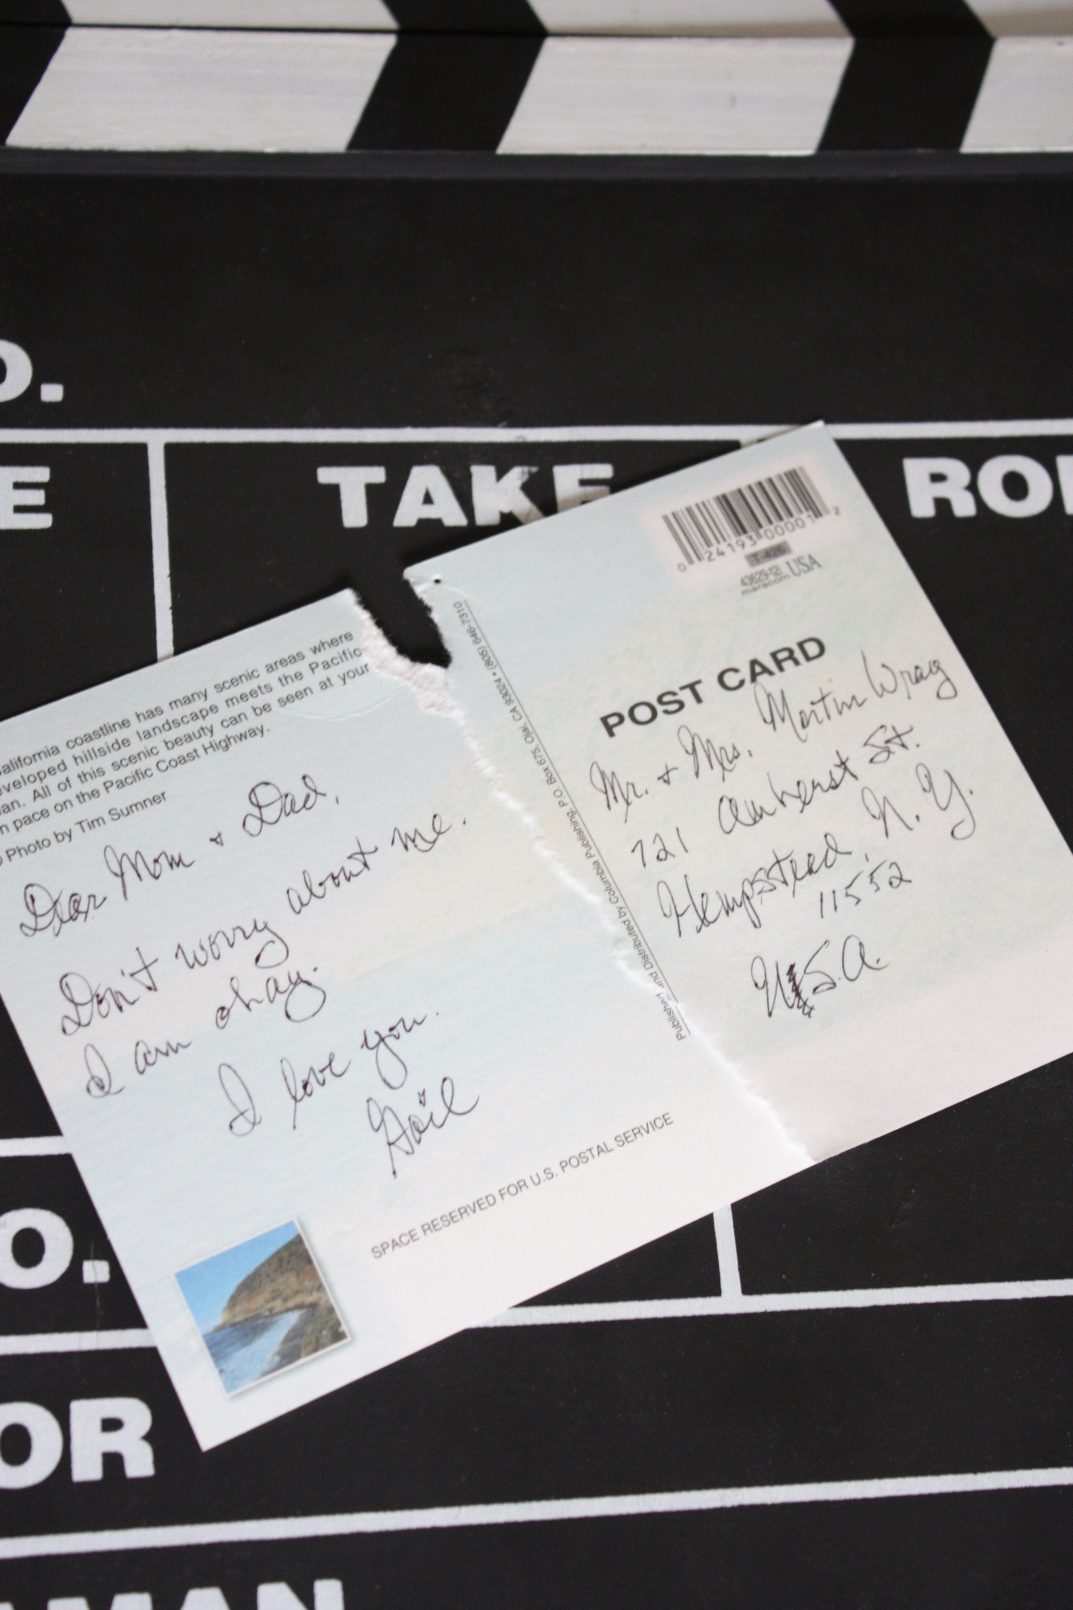

a short novel

APART

BOB GILLEN